democracy.exe
Can a vote ever be perfectly fair?


1. Aim
To show how the way we count votes can change who wins, and why Arrow’s impossibility theorem says no counting rule is perfect.

2. Hypothesis
- The same ballots can elect different winners under different counting rules.
- No ranking-based rule is fair in every election with three or more candidates.

3. Mathematical background
Each student ranks the candidates. Aarav ≻ Meera ≻ Kabir means Aarav is preferred to Meera, and Meera to Kabir. With n candidates there are n! possible rankings:
3! = 3 × 2 × 1 = 6
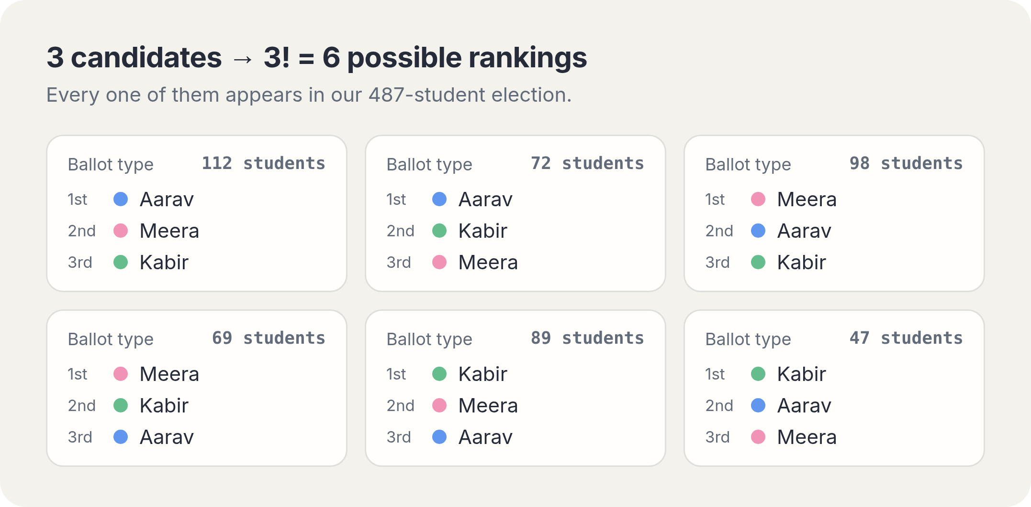
Counting rule | How it works | Winner
One name each | Most first choices wins. | ● Aarav 184 (38%)
Instant runoff | Knock out last place, move their votes to the next choice. | ● Meera 256 – 231
Points (Borda) | 2 points for 1st, 1 for 2nd, 0 for 3rd. | ● Meera 535 points

4. The spoiler effect
If Kabir drops out, nobody changes their mind about Aarav or Meera. But Kabir’s 136 votes move to their next choice, and more of them go to Meera.
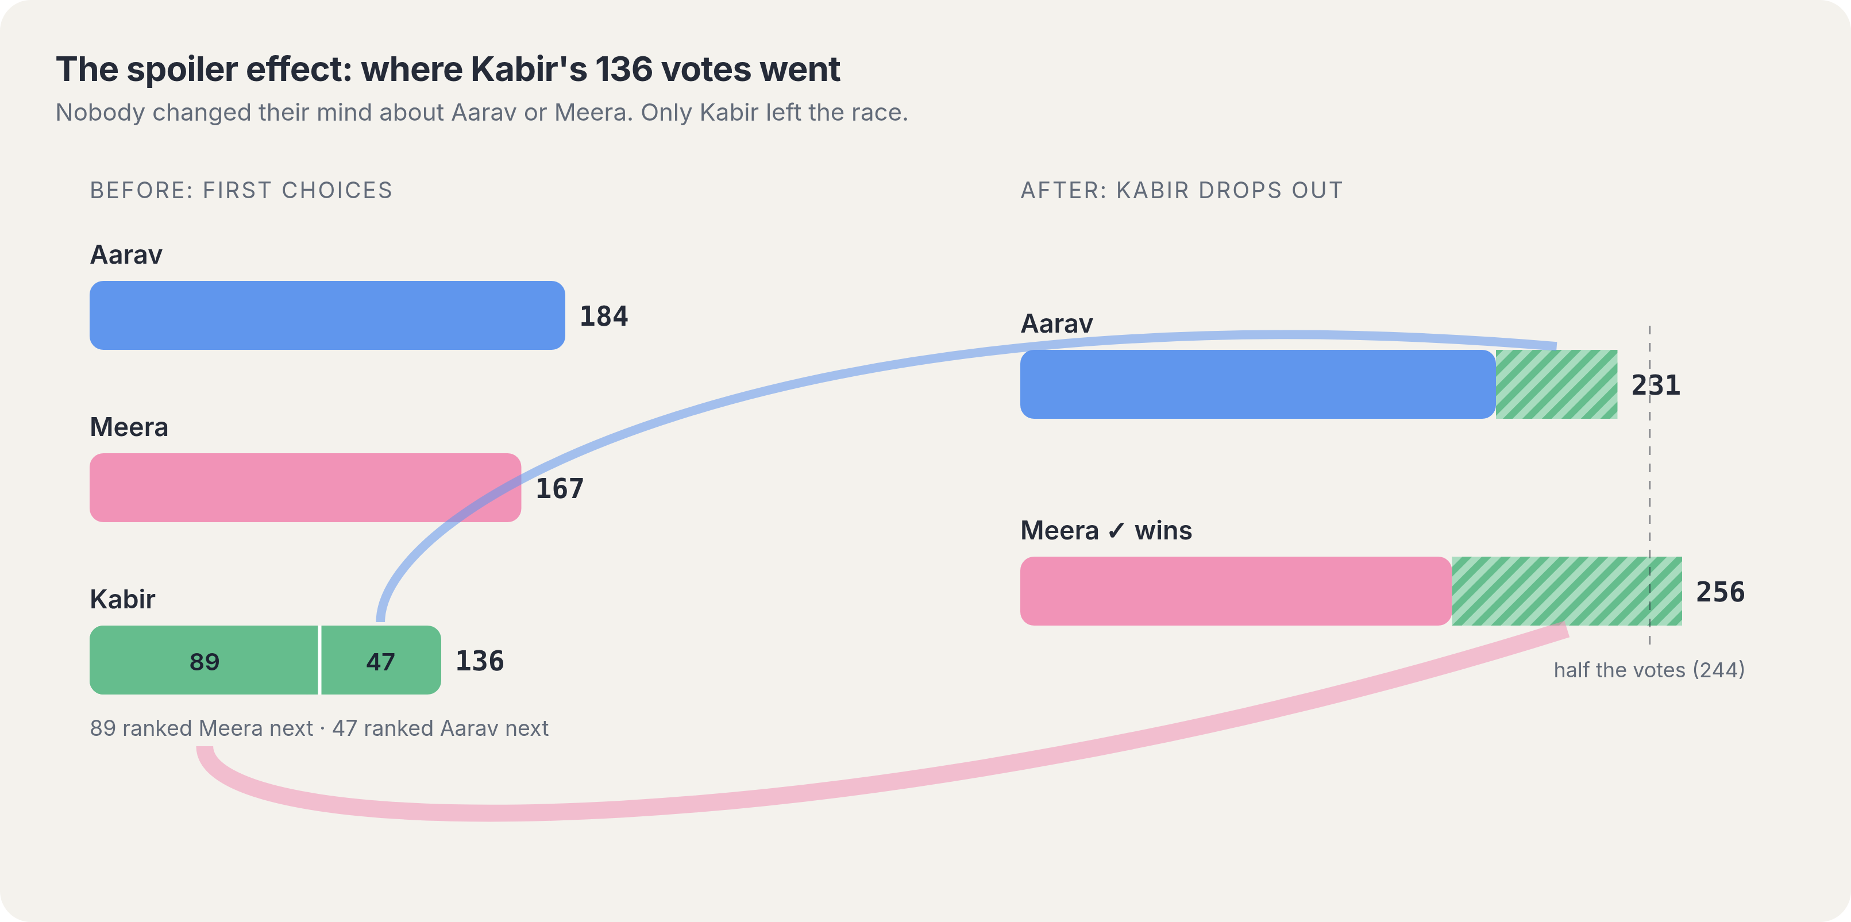
Aarav: 184 + 47 = 231 Meera: 167 + 89 = 256 ✓
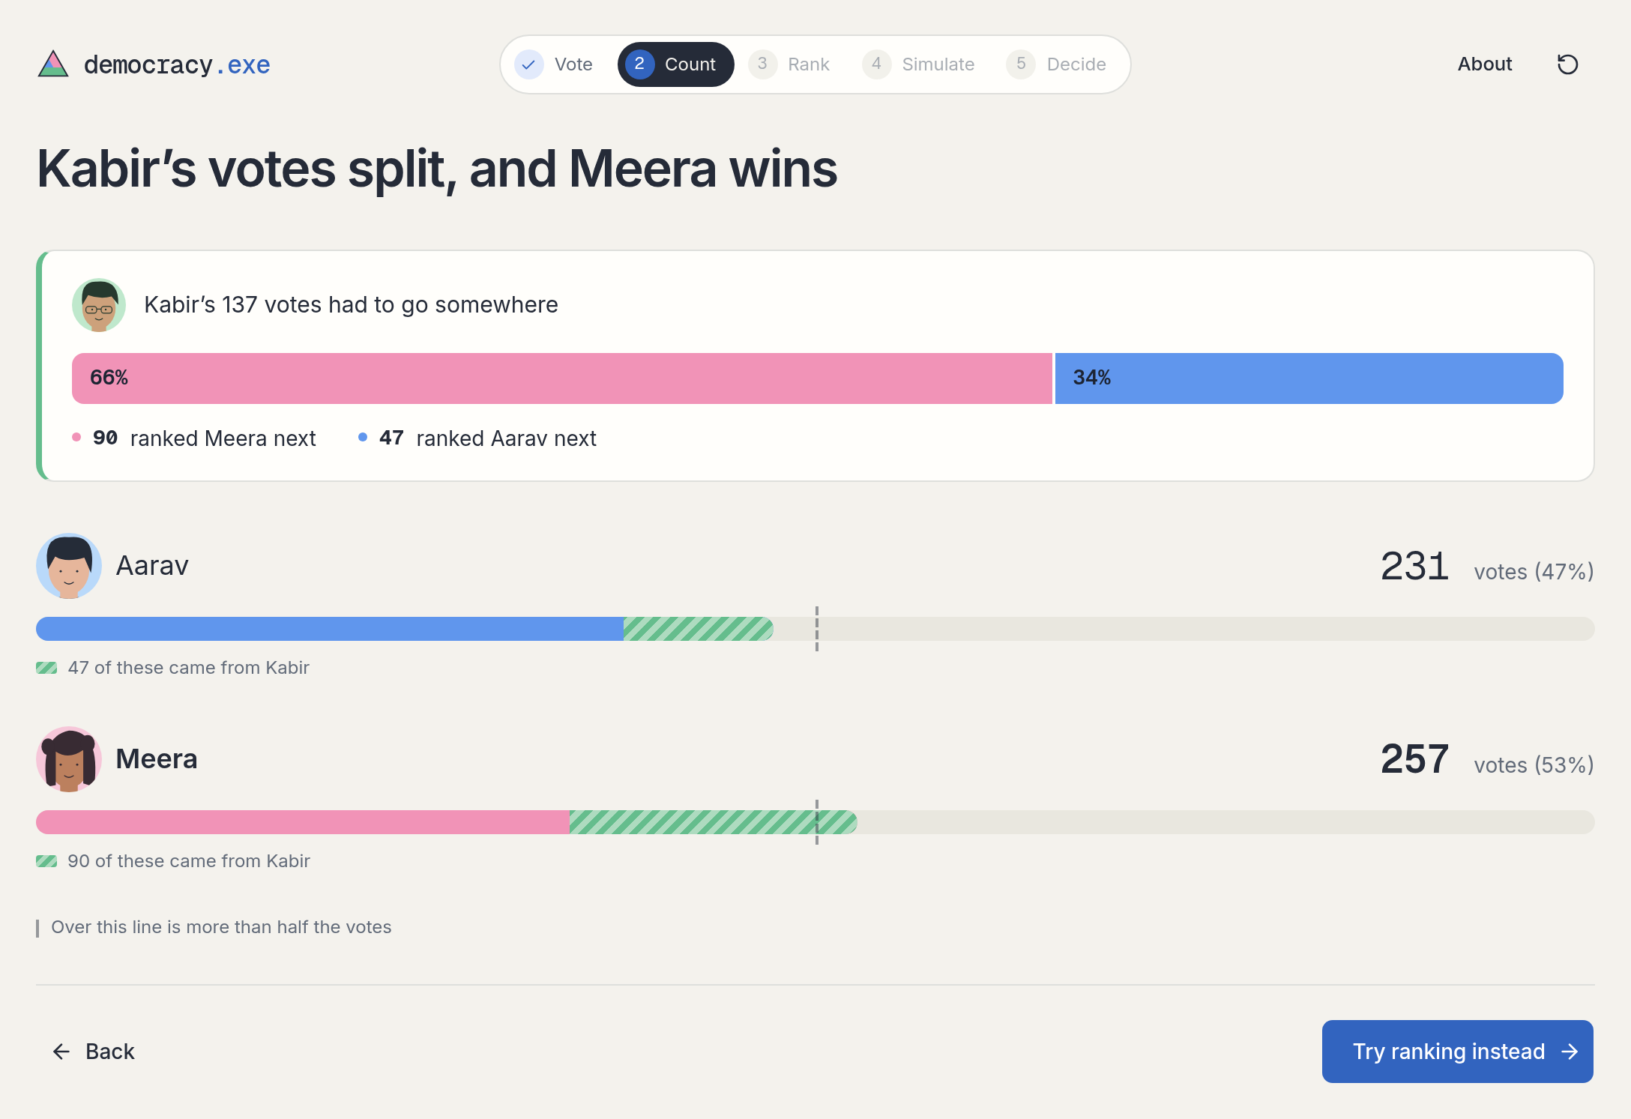

5. The Condorcet paradox
Majorities can go round in a circle, like rock, paper, scissors. Each student’s own ranking makes sense, but the group’s does not. This breaks transitivity.
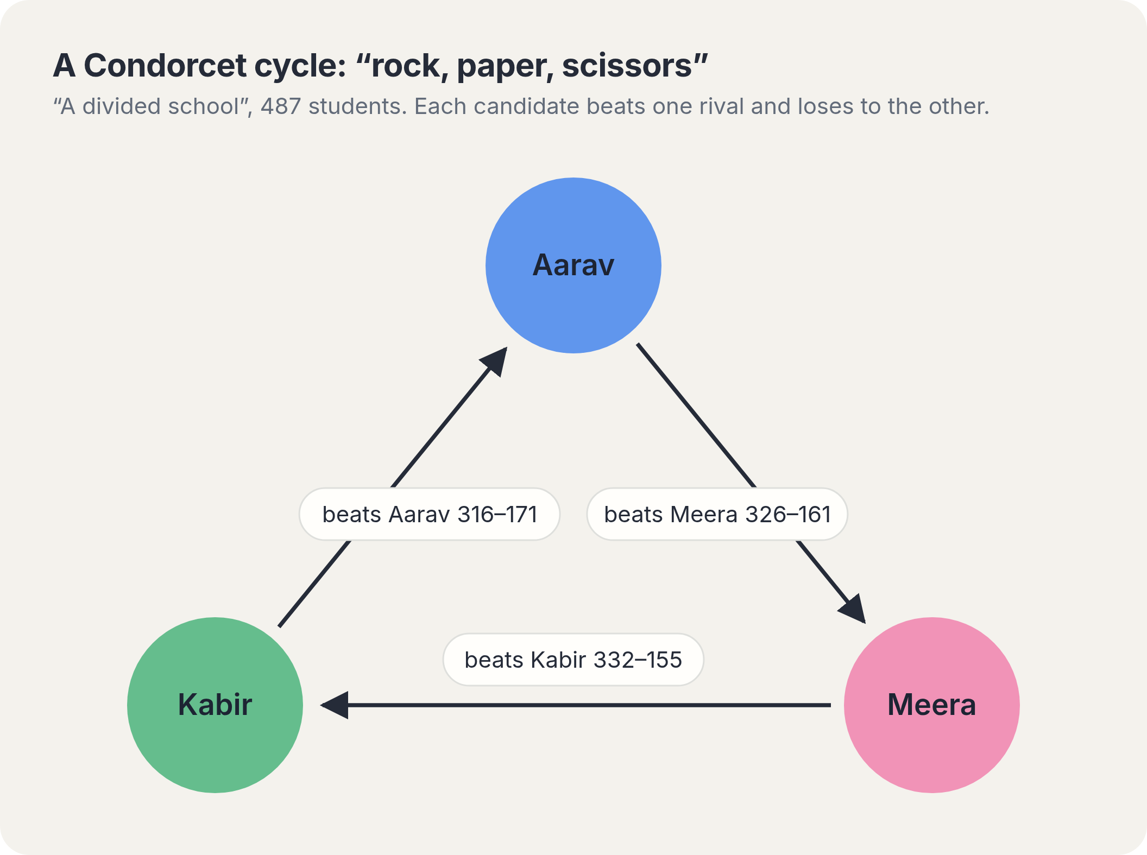

6. Arrow’s impossibility theorem
Kenneth Arrow (1951) proved that with three or more candidates, no ranking-based voting rule can satisfy all five of these conditions in every election.
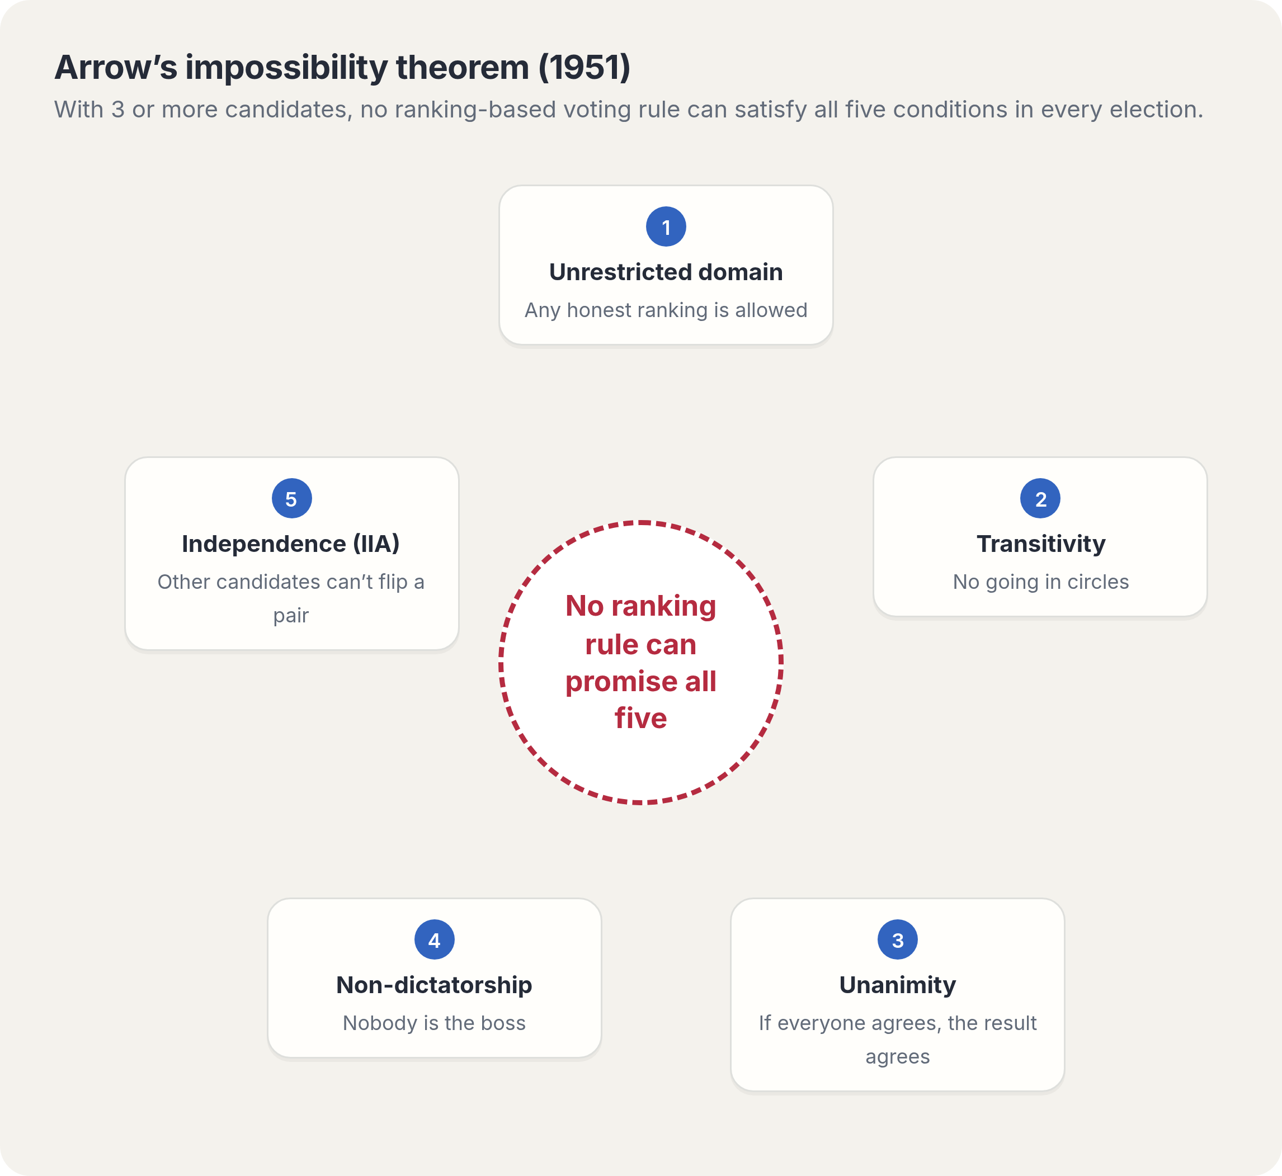

1. Unrestricted domain: every ballot counts
Any honest ranking is allowed, and the rule must work for every mix of ballots.
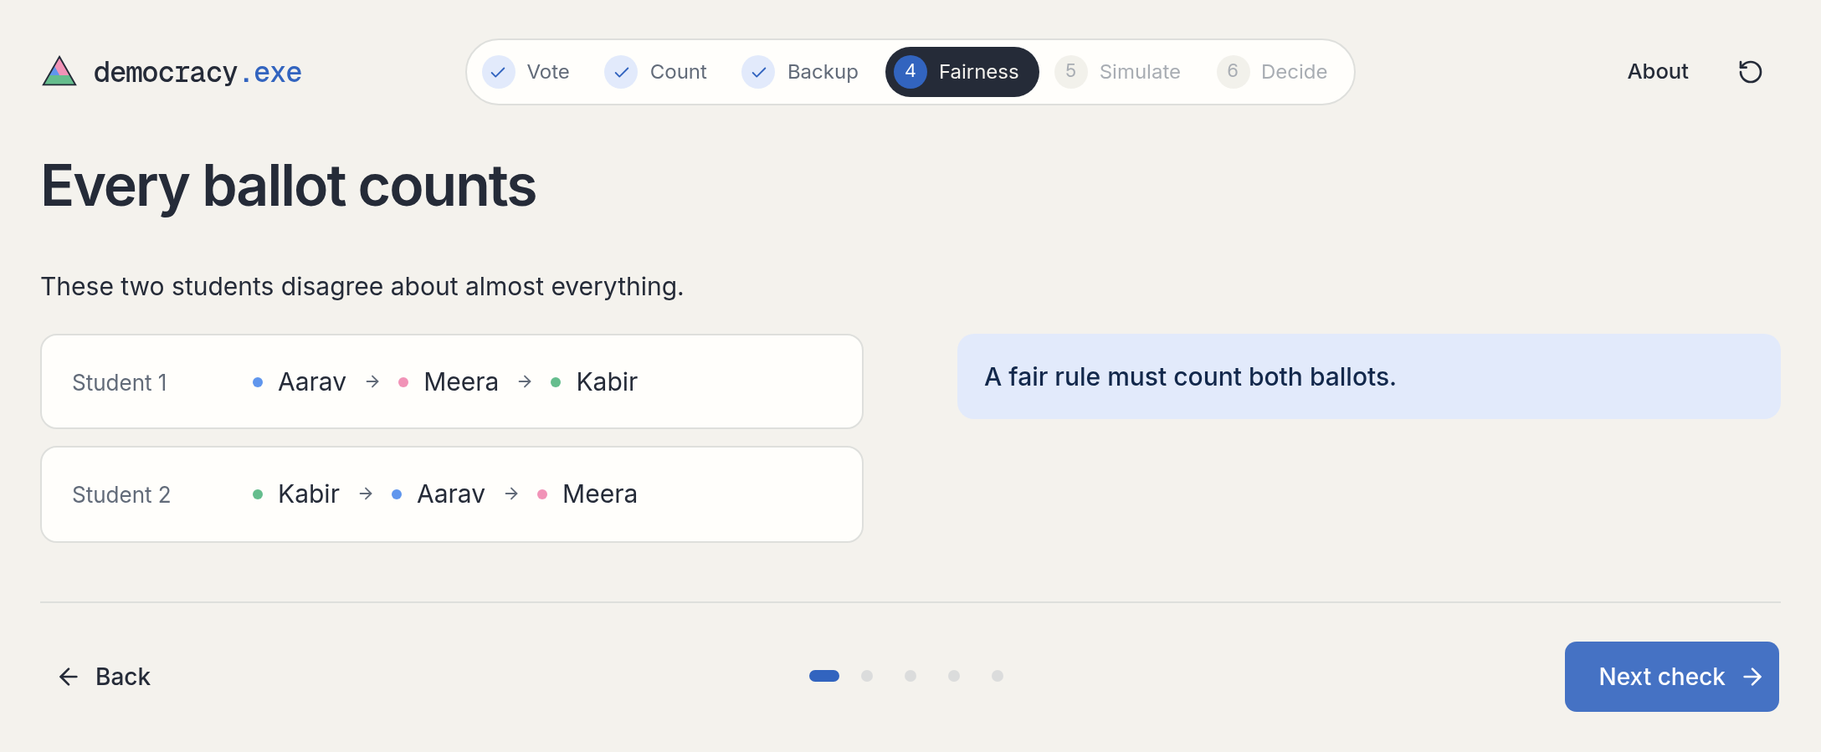

2. Transitivity: no going in circles
If the group puts Aarav above Meera and Meera above Kabir, Aarav must be above Kabir.
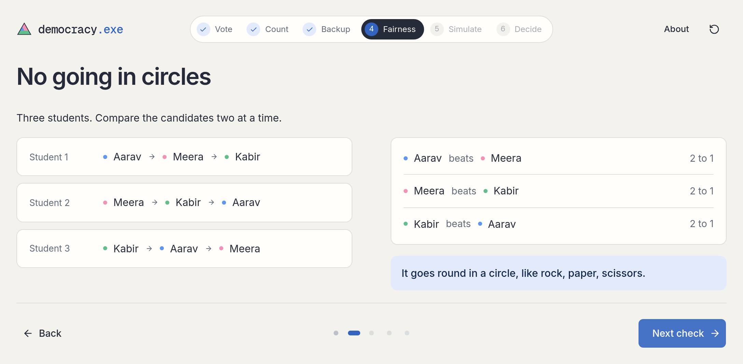

3. Unanimity: if everyone agrees, the result agrees
If every student prefers Aarav to Meera, so must the result.
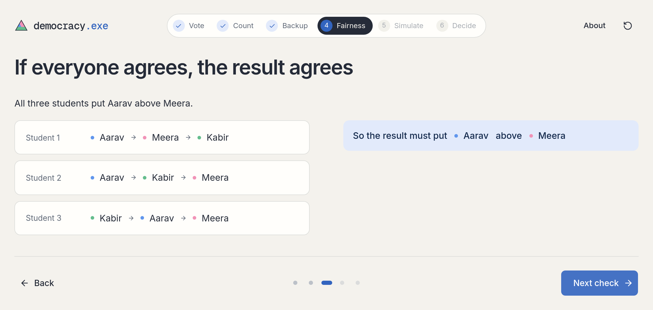

4. Non-dictatorship: nobody is the boss
The rule can’t just copy one student’s ranking.
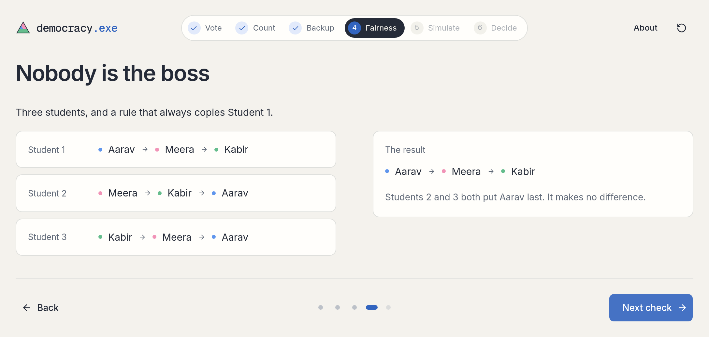

5. Independence of irrelevant alternatives
Moving Kabir shouldn’t change whether Aarav or Meera is ahead. With Borda points it does: Meera leads 7 to 6, then Aarav leads 6 to 4, though nobody changed their mind about the two of them.
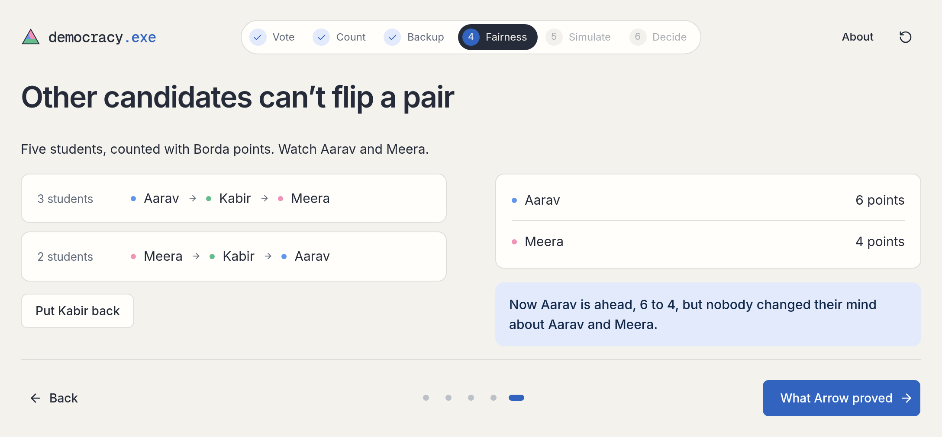

Every rule breaks something
Rule | Breaks
One name each | Independence: Kabir dropping out flips the winner
Instant runoff | Independence: a losing candidate can change who wins
Points (Borda) | Independence: moving Kabir flips Aarav vs Meera
Head-to-head majority | Transitivity: results can go in a circle

7. Conclusion
In our election, Aarav wins on first choices, but Meera wins with instant runoff and with points. Kabir couldn’t win, yet he decided the result. Arrow’s theorem shows this isn’t a flaw of one rule: every ranking rule must break at least one fairness condition.
There is no perfect voting system, only trade-offs.

